

Thin Layer Chromatography - Laboratory Protocol

- Each pair should have the following items:

  - Pestle and mortar
  - Some leaf material (e.g. basil plant)
  - Sample tube containing propanone (acetone, 750 μL)
  - Ruler and pencil
  - Pasteur pipette or glass capillary tube (CARE – sharp!)
  - Beaker (600 cm³) containing 5 cm³ of solvent mixture (cyclohexane: propanone: petroleum ether (40-60ºC boiling point range) [5:3:2] covered with Al foil lid

- Tear off approximately 1 cm² of the leaf material and grind it using the pestle and mortar. Add acetone (750 μL) to form a green liquid. Pour this liquid back into the sample tube (try to avoid transfer of too much solid material at this stage) and re-cap the tube.

- Preparation of the TLC plate.
The plate measures approximately 10 cm x 5 cm.

Place the plate on a flat surface and using a pencil make a faint mark at either edge of the plate 1.5 cm from the bottom of the plate (corresponding to the two red lines in the schematic shown).

You may want to practise this application step! Load supernatant (trying to avoid collection of any cellular debris) as a series of small drops as shown (i.e. one series of drops is to be loaded 1-2 cm from the left hand edge of the plate and the second series of drops is to be loaded 3-4 cm from the left hand edge of the plate). Several applications may have to be made to produce a dark green strip.

N.B. Try to avoid any drops being larger than 0.5 cm diameter.

Avoid digging the pipette tip into the plate.

- Place the thin layer plate into the beaker and replace the Al foil. Remove the plate when the solvent is near the top and immediately mark the solvent front with a pencil mark on the edge of the plate. Mark the position of the pigments as soon as the solvent has dried (they fade with time, especially in the light). Use the UV lamp to see if further bands can be identified.

Student Results

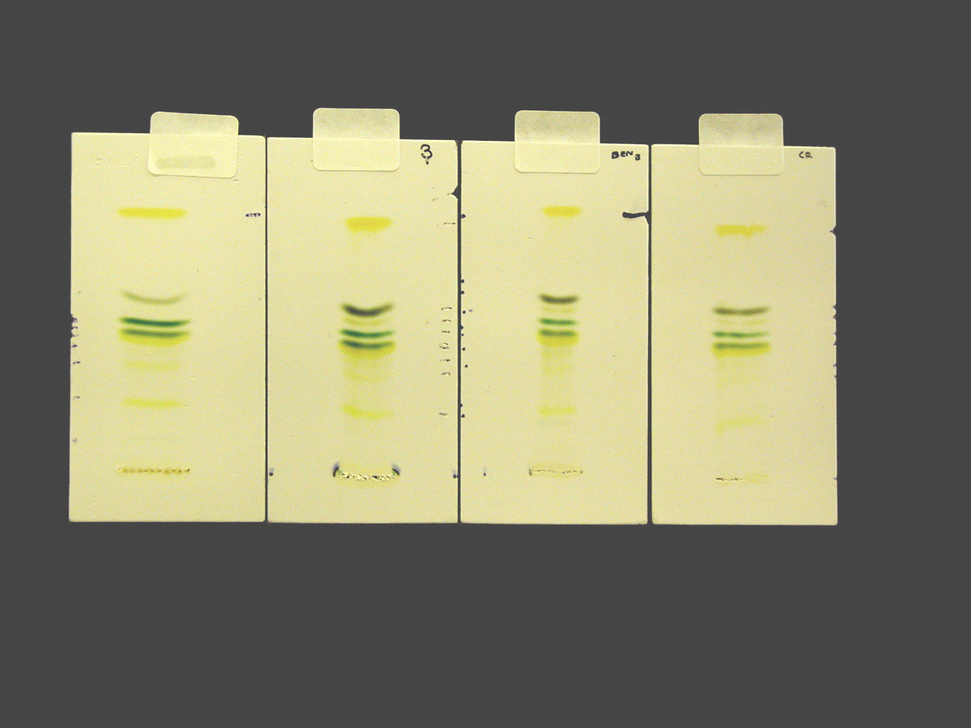

Pigment | Colour | R_{F} value
Carotene | Yellow-orange | 0.91
Pheophytin | Grey | 0.75
Pheophytin | Light-grey | 0.63 - 0.75
Chlorophyll a | Blue-green | 0.63
Chlorophyll b | Green | 0.58
Xanthophylls | Yellow | 0.53
Xanthophylls | Yellow | 0.47
Xanthophylls | Yellow | 0.32

Note: Thin layer chromatography (TLC) of photosynthetic pigments is one of the practicals suggested in the learning activities section of CfE Higher Biology [1]. The theory of thin layer chromatography as a separation technique is also included under the mandatory course key area ‘Laboratory techniques for biologists’ in the ‘Cells and Protein’ Unit of Advanced Higher Biology [2]. If appropriate, Advanced Higher students could use TLC as a technique in carrying out their Advanced Higher Investigation.

